**5 Easy Steps to Paint Your Room**

All of us at some point in our lives have wanted to paint our room in the colours we want and with the designs we thought would make us happy. In this article, we highlight the 5 most important aspects of how to paint your room. However, there are some things you need to know before you pick up that brush and start painting. There is a reason we hire professional painters for our walls because we want smooth, long-lasting wall paint that looks appealing. So even though you can do a good enough job for painting your room, it is always a good idea to consult someone before taking the plunge into that paint bucket! There are so many online consultants, and advice available around the clock for DIY paint your room ideas.

1. **Start with a Fresh Surface**

It is crucial to start with a fresh surface before you paint. Experts recommend that you should first scrub off all the old paint, and prime your walls. Remove all the dust and grime, use a good quality primer to fill in the gaps and holes and let dry. A smooth base gives the best finish to the paint. When personalising your room, each step should be planned and well-executed. Using TSP solution for cleaning also slightly etches the paint, which helps the paint to bond better.

1. **Paint the Trim First, Then the Ceilings and Walls**

Protect the window ledges and corners with painter's tape. Start painting the trim first, and then the rest of the wall surface in long smooth strokes of your brush. It is also a good idea to paint the ceiling followed by the walls. While painting the trim, remove the masking tape, wait for the wall to dry, before applying tape to the walls. You can begin with the trim near the ceiling, move on to door and window frames, and round off at the baseboards.



1. **A good, clean paintbrush is your best friend**

The edges of the woodwork can be painted using an angled brush or sponge tool, while the central surface can be filled with a roller in overlapping M or W-shaped strokes for even paint distribution. It is good practice to cover the tray and brush with a plastic wrap between coats. Rinse your paint tray, rollers and brushes under running water to clean them, if you are not throwing them away. Once dry, store them in original paper and secure with tape, to keep them from fanning out. Pour the remaining paint into the can and close the lid securely.

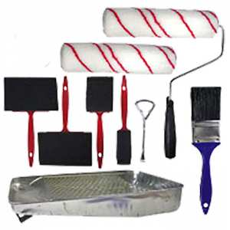

1. **Let dry and apply multiple coats**

Normally, going from a dark wall to a lighter shade will require one coat of primer and at least two coats of paint. In the opposite case, good results can be achieved with two coats of good quality paint. It is important to wait for a minimum of 6 hours between subsequent coats of paint. Touch the wall to see if dry and then move on to the next coat. Always use good quality paint for ample coverage and long-lasting professional finish. You can add extenders to your paint so that it dries slower but prevents stroke marks.

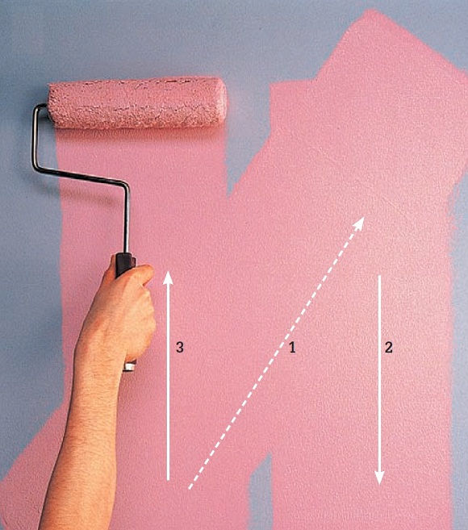

1. **Modern Accent Wall Design Planning**

Planning to paint a bold design on one wall? Or an accent wall with motifs, or texture? It is very common these days to have a focal wall which requires different expertise and design skills to compliment your colour scheme and the general setting and purpose of the room. First, paint the adjoining solid-coloured walls. Once dry, tape off the edges of those walls. Make sure to tackle only one wall at a time. 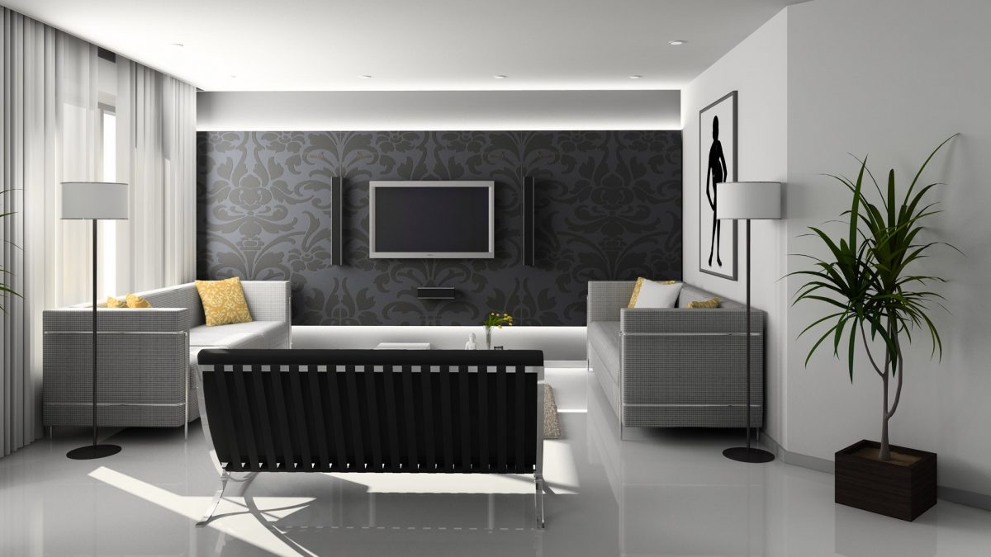

You can complete painting your room in a matter of one day if you plan well. Hope these tips for planning how to paint your room were helpful. Being an amateur, it is common to have some doubts about how to paint your room fast and easy. Online tools are powerful visualizers that let you see your finished look before picking up the brush. Leave a comment about your experience painting your room, or any other helpful tips. Happy painting!

If this is your first time painting a room, you could read this article on *how to narrow down the good colours to paint your room.*

Next Read:

Keywords:

**Accent wall** paint your room ideas **Personalising your room** **how to paint your room fast and easy** how to easily paint your room easiest way to paint your room easy ways to paint your room **paint for your room** paint colors for your room paint for your living room how to paint your room fast how to paint your room for cheap **good colours to paint your room** **how to paint your room**